Ex.No:5.a | DATA VISUALIZATION USING MATPLOTLIB
Aim:

Algorithm:
Step 1: Start.
Step 2: Import the required libraries:
- pandas
- matplotlib.pyplot
- seaborn (optional)
Step 3: Create the monthly sales dataset or load it from a CSV file.
Step 4: Store the data in a Pandas DataFrame.
Step 5: Display the dataset to verify that it has loaded correctly.
Step 6: Create the required visualizations:
- Line Plot
- Bar Chart
- Scatter Plot
- Histogram
- Box Plot
- Pie Chart
Step 7: Add appropriate:
- Title
- X-axis label
- Y-axis label
- Legend (if needed)
Step 8: Display each graph using plt.show().
Step 9: Analyze the visualizations to identify:
- Sales trends
- Highest sales month
- Lowest sales month
- Distribution of sales values
Program;
import matplotlib.pyplot as plt
months = ["Jan","Feb","Mar","Apr","May","Jun"]
sales = [120,150,180,170,220,250]
plt.plot(months,sales)
plt.title("Monthly Sales")
plt.xlabel("Months")
plt.ylabel("Sales")
plt.show()
Bar chart:
plt.bar(months,sales)
plt.title("Monthly Sales")
plt.xlabel("Months")
plt.ylabel("Sales")
plt.show()
pie Chart:
departments = ["HR","IT","Finance","Sales"]
employees = [25,40,20,15]
plt.pie(employees,
labels=departments,
autopct='%1.1f%%')
plt.show()
Box plot:
salary=[25000,27000,30000,
32000,35000,
40000,150000]
plt.boxplot(salary)
plt.show()
line chart:
months=["Jan","Feb","Mar","Apr"]
sales=[120,150,180,200]
profit=[20,30,40,50]
plt.plot(months,sales,label="Sales")
plt.plot(months,profit,label="Profit")
plt.legend()
plt.show()

Output:
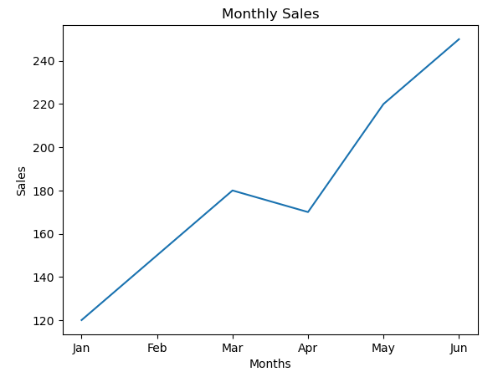
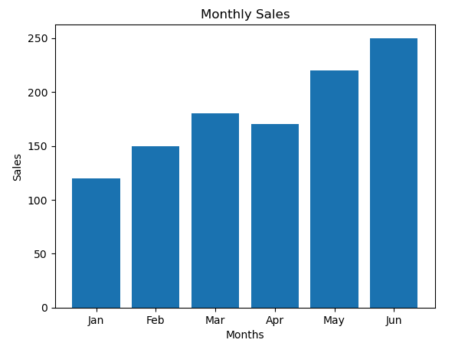
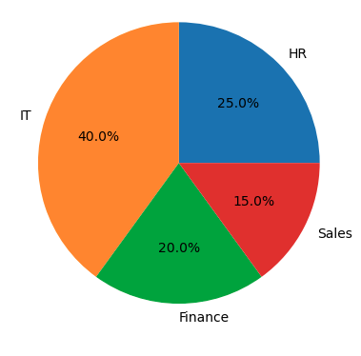
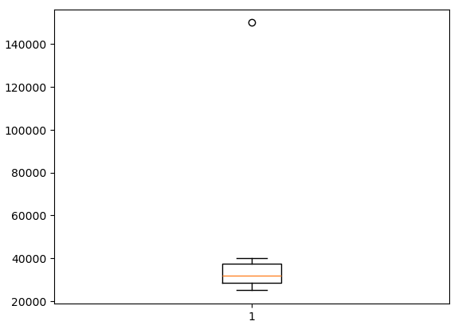
Result: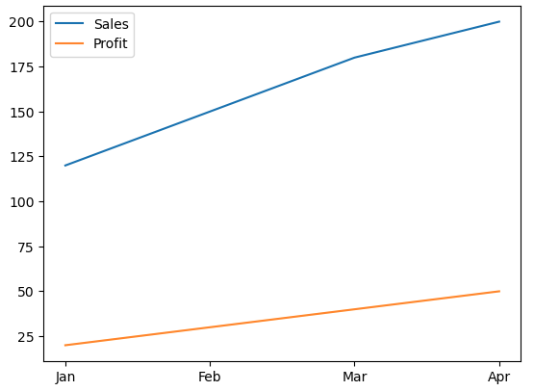

Ex.No:5.b | DATA VISUALIZATION USING MATPLOTLIB

Aim:

Algorithm:
Step 1: Start.
Step 2: Import the required libraries:
- pandas
- matplotlib.pyplot
- seaborn (optional)
Step 3: Create the monthly sales dataset or load it from a CSV file.
Step 4: Store the data in a Pandas DataFrame.
Step 5: Display the dataset to verify that it has loaded correctly.
Step 6: Create the required visualizations:
- Line Plot
- Bar Chart
- Scatter Plot
- Histogram
- Box Plot
- Pie Chart
Step 7: Add appropriate:
- Title
- X-axis label
- Y-axis label
- Legend (if needed)
Step 8: Display each graph using plt.show().
Step 9: Analyze the visualizations to identify

Program:
df = pd.read_csv(r"C:\Users\HP\Downloads\archive\automobile_dataset.csv")
import pandas as pd
import matplotlib.pyplot as plt
import seaborn as sns
# 1. Line Plot - Year vs Selling Price
plt.figure(figsize=(8,5))
plt.plot(df["Year"], df["Selling_Price"], alpha=0.6)
plt.title("Line Plot: Year vs Selling Price")
plt.xlabel("Year")
plt.ylabel("Selling Price")
plt.grid(True)
plt.tight_layout()
plt.show()
# 2. Box Plot - Selling Price
plt.figure(figsize=(6,5))
plt.boxplot(df["Selling_Price"].dropna())
plt.title("Selling Price Box Plot")
plt.ylabel("Selling Price")
plt.tight_layout()
plt.show()
# 3. Histogram - Mileage Distribution
plt.figure(figsize=(8,5))
plt.hist(df["Mileage"].dropna(), bins=20, edgecolor="black", color="skyblue")
plt.title("Mileage Distribution")
plt.xlabel("Mileage")
plt.ylabel("Frequency")
plt.tight_layout()
plt.show()
# 4. Violin Plot - Selling Price
plt.figure(figsize=(6,5))
plt.violinplot(df["Selling_Price"].dropna())
plt.title("Selling Price Violin Plot")
plt.ylabel("Selling Price")
plt.tight_layout()
plt.show()
# 5. Line Plot - Selling Price Trend (by index)
plt.figure(figsize=(10,5))
plt.plot(df.index, df["Selling_Price"], color="red", alpha=0.7)
plt.title("Selling Price Trend")
plt.xlabel("Record Index")
plt.ylabel("Selling Price")
plt.grid(True)
plt.tight_layout()
plt.show()

# 6. Stack Plot - Engine Size & Horsepower
plt.figure(figsize=(10,5))
plt.stackplot(
df.index,
df["Engine_Size"].fillna(0),
df["Horsepower"].fillna(0),
labels=["Engine Size", "Horsepower"]
)
plt.title("Engine Size and Horsepower")
plt.xlabel("Record Index")
plt.ylabel("Values")
plt.legend(loc="upper left")
plt.tight_layout()
plt.show()
# 7. Line Plot - Mileage by Index
plt.figure(figsize=(12,5))
plt.plot(df.index, df["Mileage"], color="green", alpha=0.7)
plt.title("Mileage by Record Index")
plt.xlabel("Record Index")
plt.ylabel("Mileage")
plt.tight_layout()
plt.show()
# 8. Pie Chart - Fuel Type Distribution
fuel = df["Fuel_Type"].value_counts()

plt.figure(figsize=(7,7))
plt.pie(fuel,
labels=fuel.index,
autopct="%1.1f%%",
startangle=90)
plt.title("Fuel Type Distribution")
plt.tight_layout()
plt.show()
# 9. Subplots (2x2)
fig, ax = plt.subplots(2, 2, figsize=(12, 8))

# Line Plot
ax[0,0].plot(df.index, df["Selling_Price"], color="purple", alpha=0.6)
ax[0,0].set_title("Line Plot - Selling Price")

# Histogram
ax[0,1].hist(df["Year"].dropna(), bins=15, edgecolor="black", color="orange")
ax[0,1].set_title("Histogram - Year")

# Box Plot
ax[1,0].boxplot(df["Mileage"].dropna())
ax[1,0].set_title("Box Plot - Mileage")

# Scatter Plot
ax[1,1].scatter(df["Engine_Size"], df["Horsepower"], alpha=0.5)
ax[1,1].set_title("Scatter - Engine Size vs Horsepower")
ax[1,1].set_xlabel("Engine Size")
ax[1,1].set_ylabel("Horsepower")

plt.tight_layout()
plt.show()
# 10. Seaborn Scatter Plot
plt.figure(figsize=(8,5))
sns.scatterplot(data=df, x="Mileage", y="Selling_Price", alpha=0.6)
plt.title("Mileage vs Selling Price (Seaborn)")
plt.tight_layout()
plt.show()
Output:
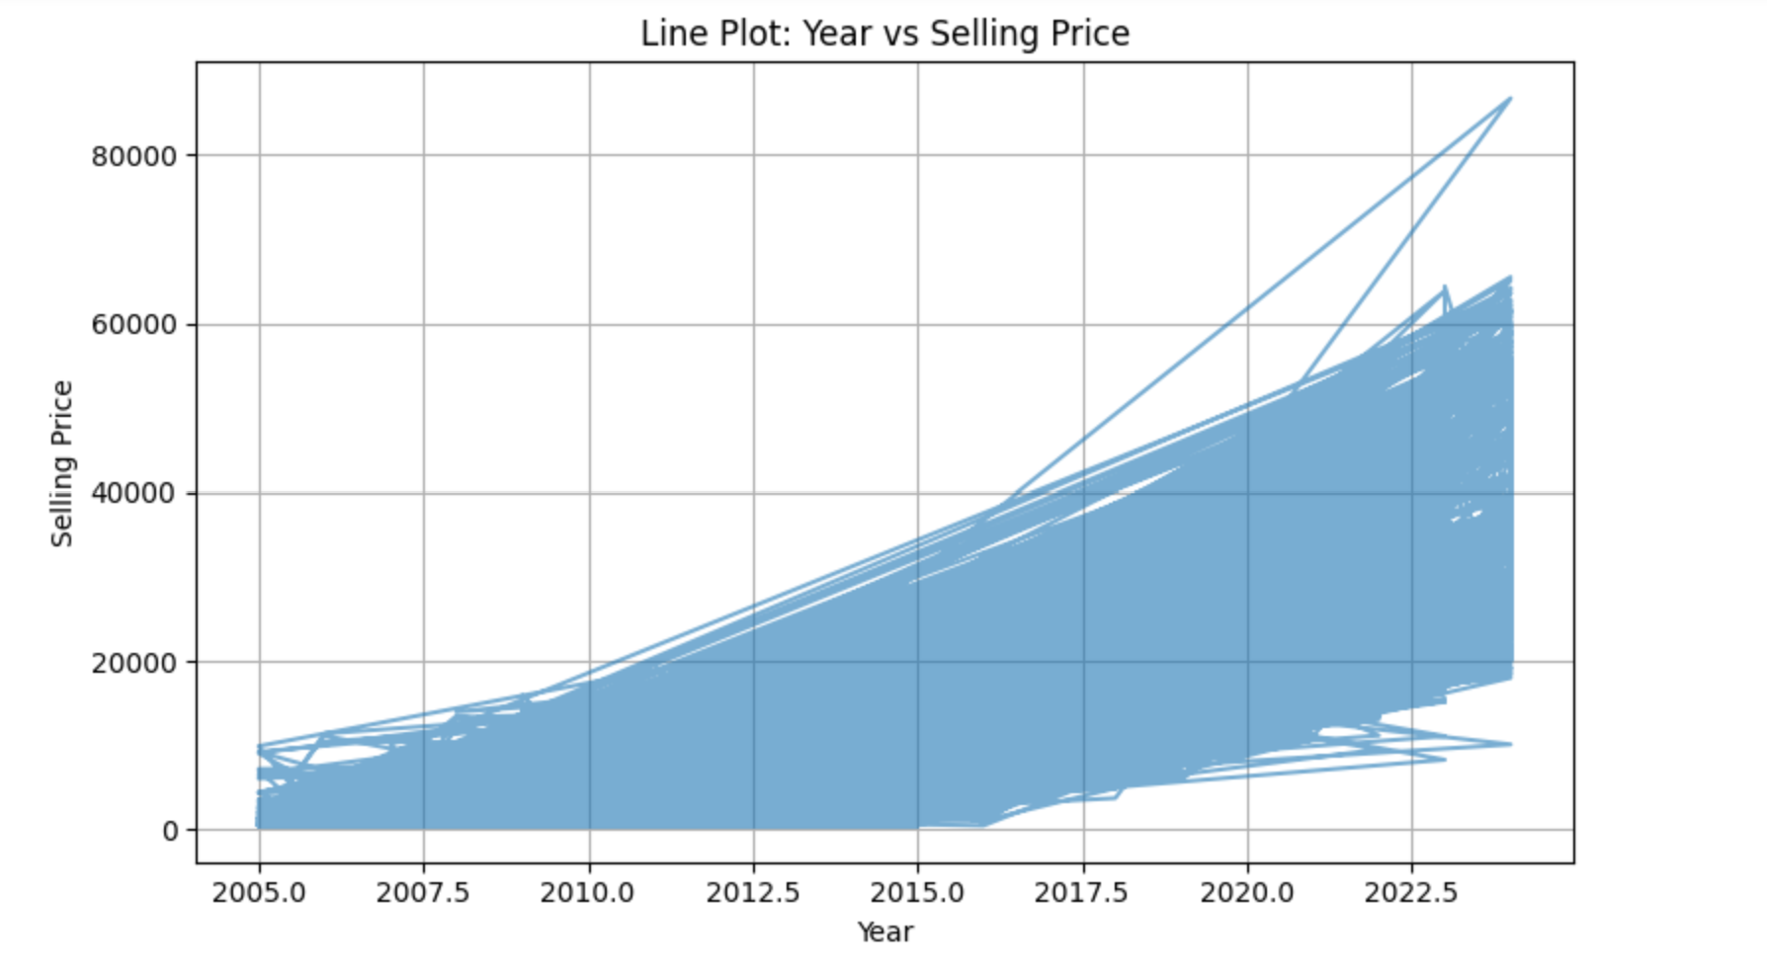
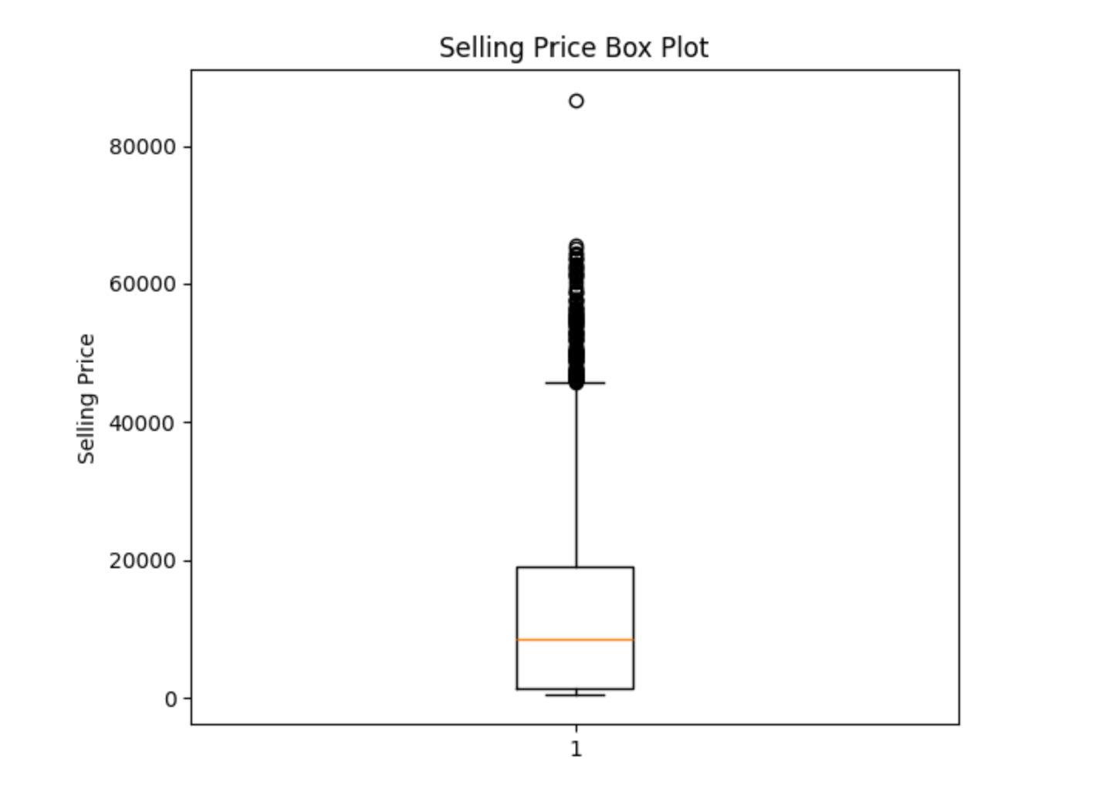

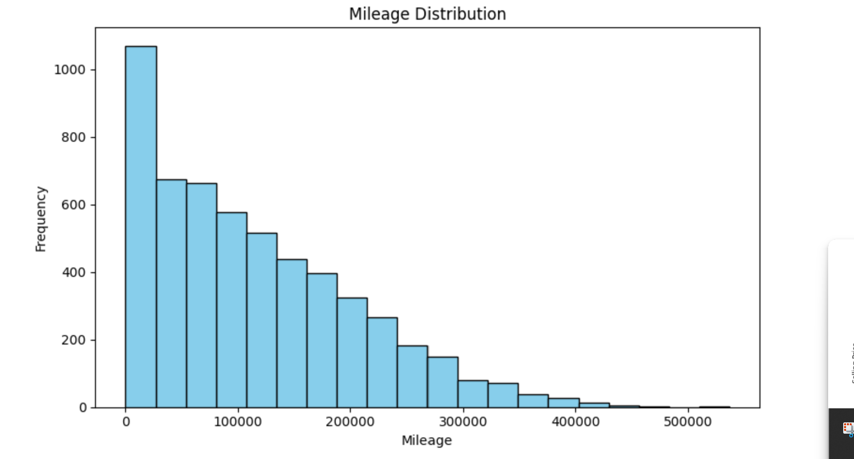

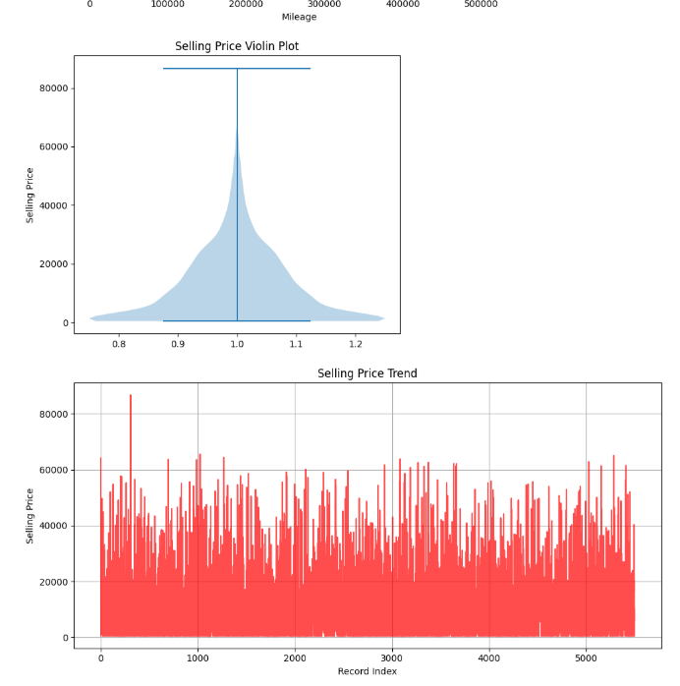
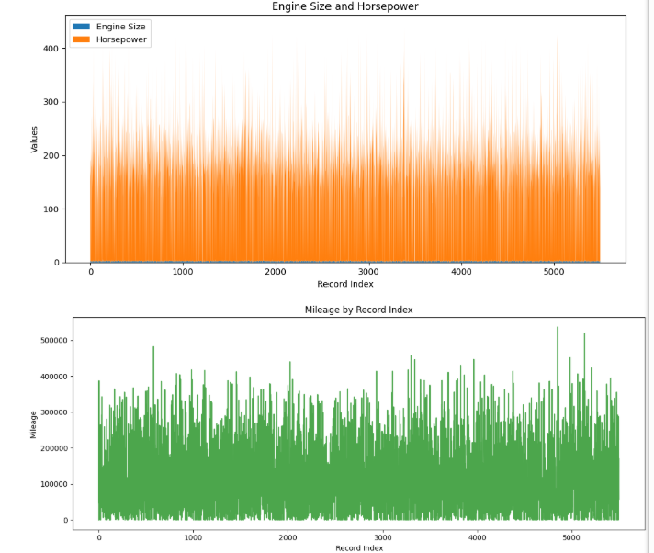
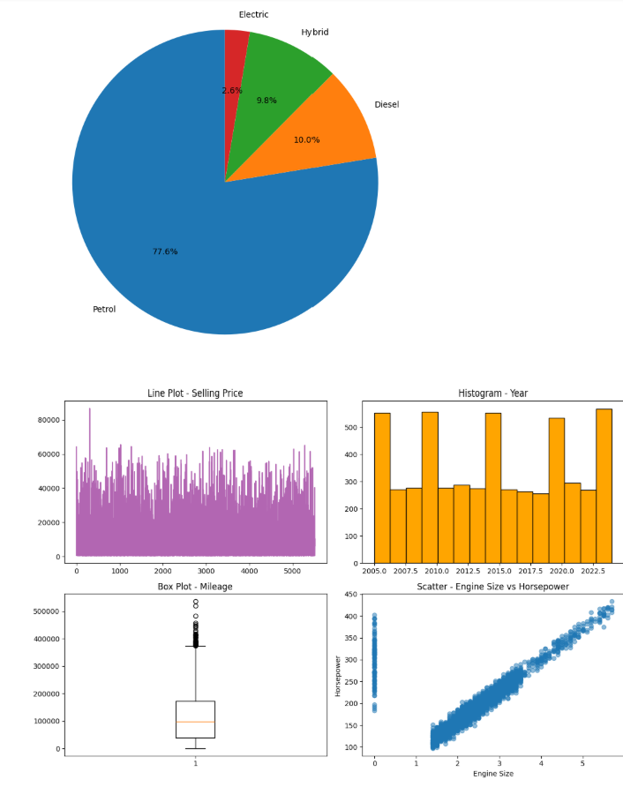
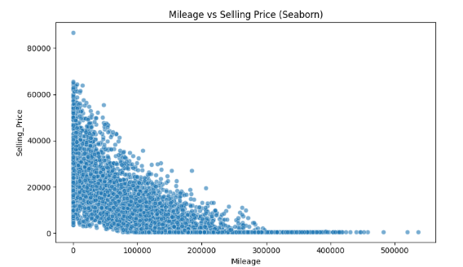

Result:

